Consolidated Peer Evaluation Form

Instructions:

1. This evaluation form must be accomplished by the group members after an ***open deliberation*** conducted among the group members, with every member in attendance and concurring with the results.
2. Under the first column, write down the names, ***in alphabetical order by family name***, of all the group members.
3. For each group member, write down, under the columns **C1** through **C5**, the ***objective evaluation*** of the member, for each of the indicated criteria, using the specified numeric rating scale. Write down the total evaluation (i.e., the ***sum*** of **C1** through **C5**) for the member under the **T** column.
4. For each group member, write down, under the **Remarks** column, a ***concise phrase*** that best describes the ***“value”*** of the member to the group. In recognition of each member’s individuality, each and every group member ***must*** be provided with a ***unique*** remark.
5. In the space provided, write down the names of the group members and affix each member’s signature.
6. Cut the form along the indicated dotted line and ***submit the bottom portion only***.

Criteria: o [C1] attends scheduled group activities regularly and on time, and makes effective use of the activity period

* [C2] actively participates in group discussions, planning, and decision making, and takes responsibility for a “fair share” of the group’s workload
* [C3] completes assigned tasks and delivers quality output in a timely manner o [C4] communicates effectively and democratically with group mates
* [C5] collaborates with group mates on group tasks, and works independently on individual assignments

Rating Scale:

**5** – Excellent **4** – Very Satisfactory **3** – Satisfactory **2** – Barely Satisfactory **1** – Unsatisfactory **0** – No Rating

----------------------------------------------------------- cut along this line -----------------------------------------------------------

**Consolidated Peer Evaluation Form**

# Class Code: 9340A Schedule: 4:00-5:00 WS

|  |  |  |  |  |  |  |  |
| --- | --- | --- | --- | --- | --- | --- | --- |
| Names of Group Members  (family name first,  In alphabetical order) |  | Criteria | | |  | T | Remarks |
| C1 | C2 | C3 | C4 | C5 |
| CARABIT, Jeco | 5 | 3 | 4 | 4 | 3 | 19 | Generous groupmate |
| CASTILLO, April Joy | 5 | 3 | 4 | 4 | 4 | 20 | Independent worker |
| DELA ROSA, Ma. Jasmin Zyrieh | 5 | 3 | 4 | 4 | 4 | 20 | Reliable assistant leader |
| PALPALLATOC, Windee | 4 | 2 | 3 | 3 | 3 | 15 | Calm groupmate |
| PADSUYAN, Jones | 5 | 3 | 4 | 4 | 4 | 20 | Responsible leader |
| TAASIN, Jargon | 5 | 3 | 4 | 5 | 5 | 22 | Instructive groupmate |
|  |  |  |  |  |  |  |  |

***We, the undersigned, attest to the objectivity of the foregoing evaluations.***

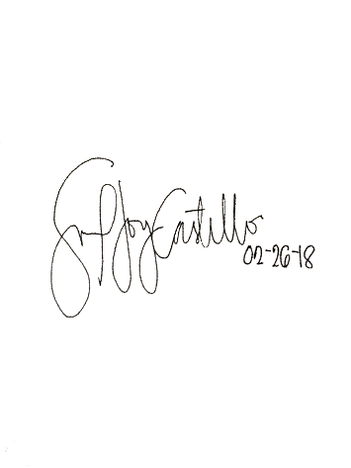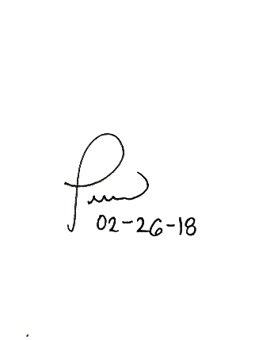

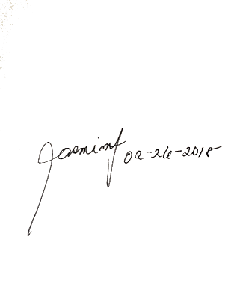

**Evaluators:** CARABIT, Jeco CASTILLO, April Joy DELA ROSA, Ma. Jasmin Zyrieh

**(signatures over printed names/date signed)**

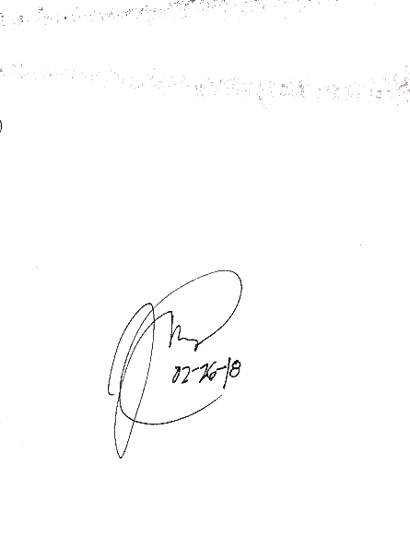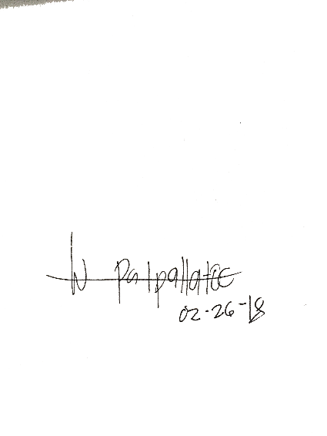

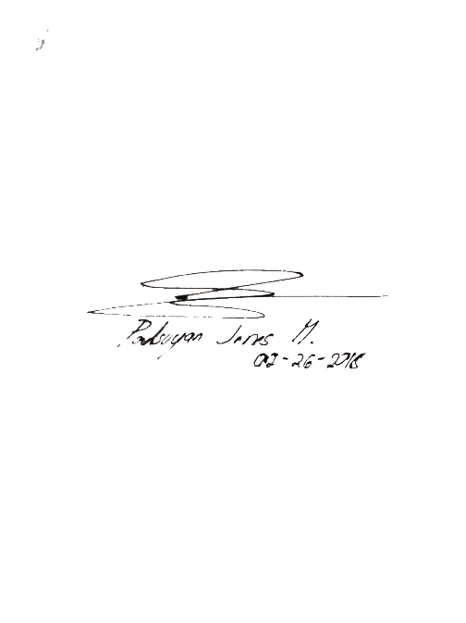

PALPALLATOC, Windee PADSUYAN, Jones TAASIN, Jargon

# (signatures over printed names/date signed)